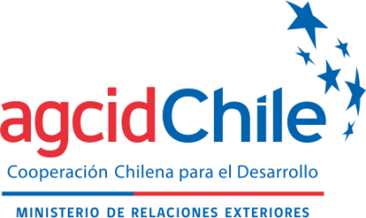 | 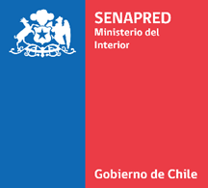

ANNEX II

PROPOSED ACTION PLAN

- Presentation

Resilient and Sustainable Societies in the Face of Disasters in Latin America and the Caribbean (KIZUNA II), originally promoted by the Japan International Cooperation Agency (JICA), a training line was developed aimed at strengthening governance and disaster risk management in the region, in accordance with the principles established in the Sendai Framework for Disaster Risk Reduction.

Considering the positive results achieved in previous versions and the relevance of this topic for the countries of Latin America and the Caribbean, the National Service for Disaster Prevention and Response (SENAPRED), together with the Chilean Agency for International Cooperation for Development (AGCID), have decided to continue this initiative by holding the International Course “Community Plans for Disaster Risk Management”.

In this context, and taking into account the regional reality regarding disaster risk and climate change, the program aims to strengthen the technical skills necessary for the preparation, development and/or updating of the Communal/Local Plans for Disaster Risk Reduction (DRR) and the Emergency Plans (EP), as fundamental instruments for local planning in disaster risk management.

IMPORTANT: To apply, you must fill out the following form up to point No. 6; the remaining points, 7 to 11, will be completed during the course.

The Project must include the following aspects:
- Identification : Include general background information that allows the project presented to be identified.
- Introduction: Justify the choice of the project, including who will benefit from the training, as well as explaining the potential value of the project.
- Project Name : Indicate the official name of the project or initiative.
- Project Objectives:

- General Objective : To specify the main purpose of the project, indicating the result that is expected to be achieved through the training received.
- Specific Objectives: Detail the actions, stages or activities that will be developed to achieve the general objective.
- Coverage: Indicate the place or territory where the Action Plan will be implemented, which may correspond to a commune, neighborhood, educational institution, community or other relevant space.

- Content: Describe the content and topics that will be addressed with the target community or population, aimed at strengthening the protection and preparedness of people in the face of emergency or disaster situations.
- Materials: Specify the materials, resources, and tools that will be used for the execution of the project, such as manuals, equipment, technology, audiovisual material, among others.
- Expected Learning Outcomes : Indicate the knowledge, skills and/or competencies that participants or attendees are expected to acquire through the implementation of the project.
- Methodology: Specify the project execution method, indicating the strategies and mechanisms that will be used, such as courses, workshops, training, practical activities, development of regulations or other relevant actions.
- Reference Material: Identify the supplementary and support material that will be used for the development of the project.
- Execution Time : Specify the duration and implementation schedule of the project, incorporating a Gantt chart or other time planning tool.
The above is focused on developing an action plan that is viable in their localities.

